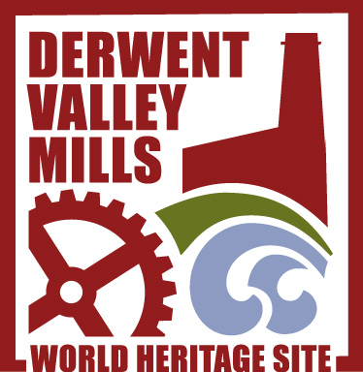

Young Entrepreneurs
Leaders Guide
Using heritage sites to develop creativity and employability skills
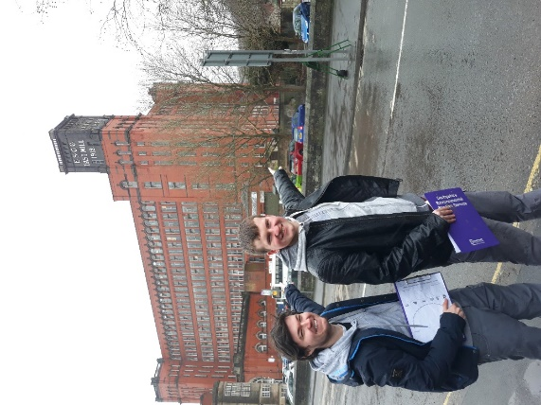
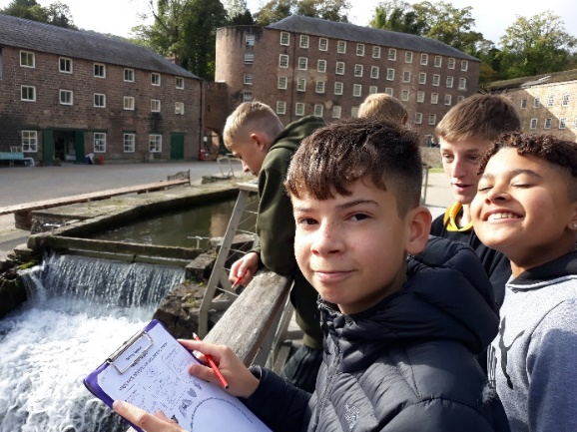
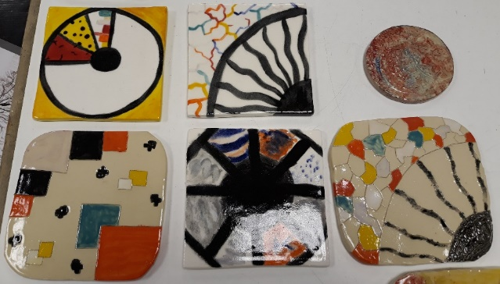
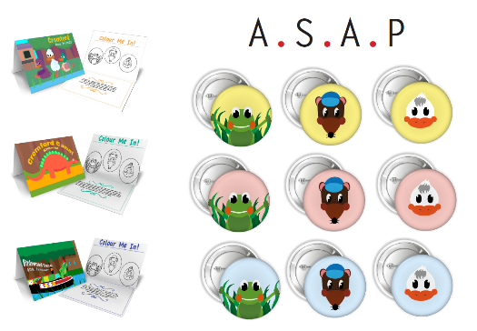
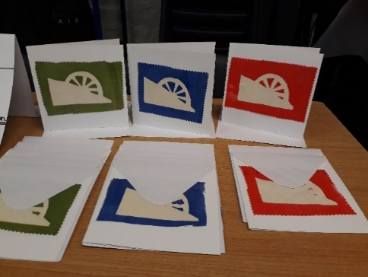
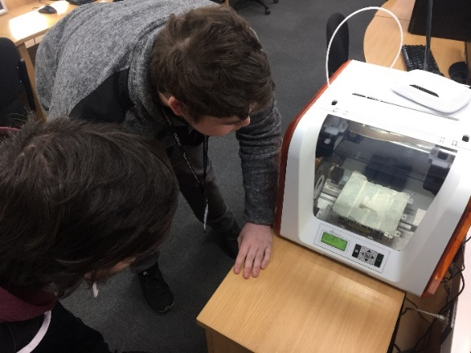

A Great Place Scheme Project 2018 – 2020
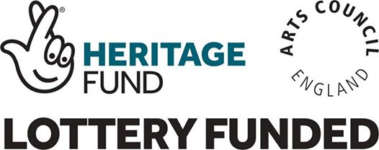

Young Entrepreneurs the context:
Young Entrepreneurs was a project developed and led by Derbyshire Environmental Studies Service between 2018 to 2020 and was one part of the Derwent Valley Mills World Heritage Site (DVMWHS) Great Place Scheme.

Funded by the National Lottery Heritage Fund, Arts Council England and supported by Historic England the Derwent Valley Mills Great Place Scheme is a programme of activities which is the next step in engaging people with the uniqueness of our Great Place.

“The programme will use the Derwent Valley Mills’ industrial heritage and spirit of innovation and making to inspire creative activities which enable people to connect and communicate with the culture and heritage at the heart of this historically significant place.

There will be a range of opportunities for people to experience, enjoy and be inspired by arts, culture and heritage in the Derwent Valley Mills World Heritage Site.”

The project aimed to:

- Work with young people of different abilities aged 11 – 21
- Use the DVMWHS, its heritage, creativity, entrepreneurial and factory production past to inspire the young creative entrepreneurs of the future.
- Develop a range of employability, transferable and creative arts skills including teamwork, co-operation, financial, production, place-based creative responses, confidence etc.
- Bring together
  - educational settings (schools, colleges, learning communities)
  - local artists and creative practitioners operating businesses in the Derbyshire area
  - Heritage Sites from across the DVMWHS
to skill share and collaborate together in a ‘real world’ project.

The Process:
The format of the project is four day sessions:
- An introductory day in the group setting or school “Being Young Entrepreneurs”.
- A “Site inspiration visit” to a location within the DVMWHS of their choosing.
- A “Production day” making and manufacturing products.
- A final “Sales event” pitching or selling products.

This Leaders Guide:

Provides a detailed framework, activity guidelines and all the resources that you can download and adapt to lead your own ‘Young Entrepreneurs’ project with a group of young people.
All the accompanying resources can be downloaded from:
http://www.derwentvalleymills.org/discovery/learning-for-all/learning-schools/teaching-resources/young-entrepreneurs-project/

You are welcome to use and adapt these resources and this process for yourself, but we request that you reference and credit Derbyshire Environmental Studies Service and the Derwent Valley Mills World Heritage Site if you do this.
www.services.derbyshire.gov.uk/EnvStudies
www.derwentvalleymills.org

Who this might be suitable for:
We worked with a wide range of groups and adapted the resources and activities to be flexible and appropriate.
- Secondary School – Year 9 students
- FE College Students – studying a digital technologies course
- FE College Students – studying graphic design
- Special School – students aged 10 – 16 years old with a wide range of learning and physical disabilities
- Study Programme students – 14 to19-year-old students not in mainstream school.

Mediums we worked in:
Prior to starting each project group we spoke with the lead staff in the settings and with the students themselves to try and provide opportunities to work alongside artists and creative practitioners. They chose mediums they might not normally get to work in (perhaps where the setting did not have facility to offer this type of artistic work) or were an area the students were hoping to progress into as a career. Once we knew which medium the students wished to work in we sought out artists and practitioners local to Derbyshire who were able and willing to work with young people and share their expertise.
- Ceramics and clay work with Elaine Lim-Newton: https://elainelimnewton.wordpress.com/
- Screen Printing with Rachael Wayne: https://www.creartii.co.uk/
- Graphic Design with Liz Handley from Graphic Results: https://www.graphicresults.co.uk/
- Digital creativity with Sharlaine Fincham: https://www.weststudios.co.uk/

Sites we worked at:
The framework of the project allowed the students to actually select as a group which site they wanted to visit from within the Derwent Valley Mills World Heritage Site. This meant us being adaptable and responsive and allowing the project to be student led.
- Belper North Mill
- Birdswood boat and the Cromford Canal
- Cromford Mills
- High Peak Junction Railway Workshops
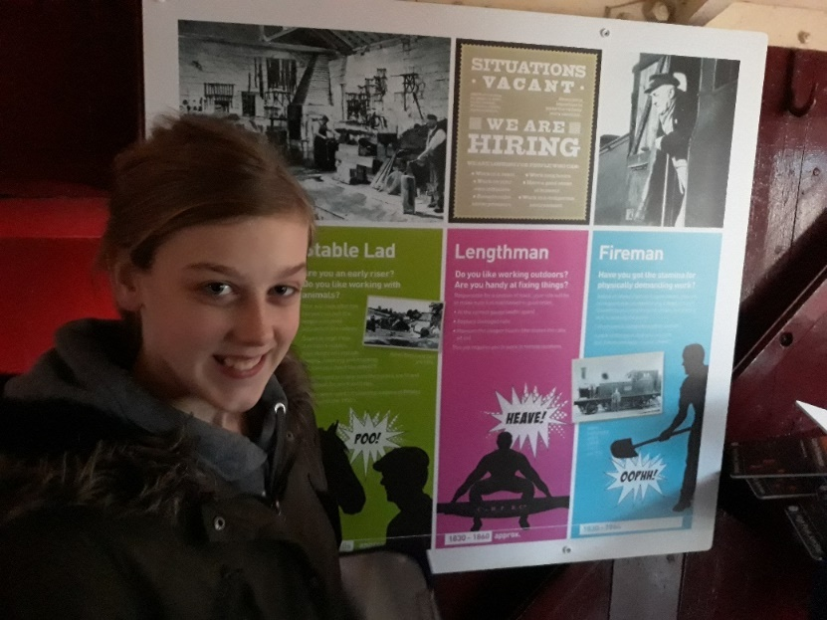

Young Entrepreneurs Leaders Pack Contents
 | Page
Delivering your own project | 5
Day 1: Being Young Entrepreneurs
How to lead the activities | 6
Suggested timetable of activities | 16
List of resources to download | 17
Day 2: Site Inspiration Visit
How to lead the activities | 18
Suggested timetable of activities | 23
List of resources to download | 25
Day 3: Production Day
How to lead the activities | 25
Suggested timetable of activities | 29
List of resources to download | 30
Day 4: Sales Event
How to lead the activities | 30
Suggested timetable of activities | 34
List of resources to download | 34

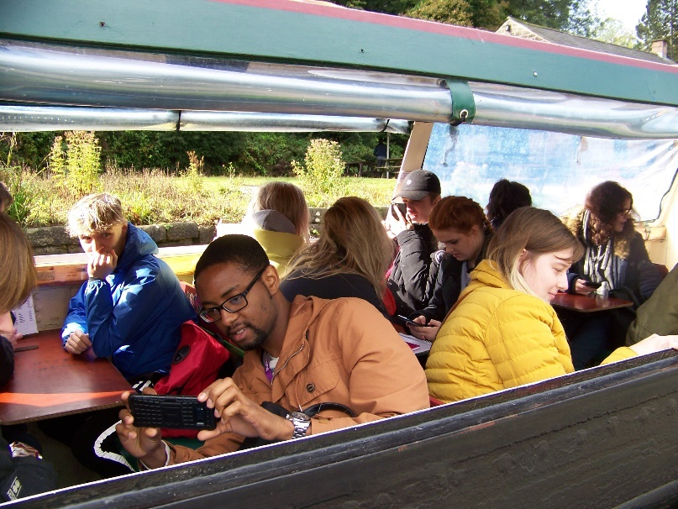

Delivering your own project.
Step 1: Preparation: Developing relationships between the heritage site, artists and school or college
- Decide which school, pupils and numbers you will be working with: A specific class or age range? A specific subject?
- Decide which site or location you will be visiting. If possible, allow the pupils to select for themselves but allow time for this between session 1 and 2. Make sure to allow time to liaise with the site learning and management staff to book your visit day, carry out a pre-visit, check accessibility and discuss needs.
- Will you allow the pupils to select which artistic medium they are working in? Or will this be dictated by the school or group? If you want to find an artist to work with artsderbyshire.org.uk/ have a list of artists you can search. Or you can do an internet search for practising art businesses in your area and contact them. Allow time to contact and brief the artists on the aims of the project.
- When all your partners are on board plan the timescale and schedule the days for your project. Think carefully about the amount of time you want the pupils to commit to the project. Will they only work on this on the project days? Or will they be expected to work on it in between your session days?
- Download the resources from the DVMWHS website and adapt them if you need to, crediting Derbyshire Environmental Studies Service and the Derwent Valley Mills World Heritage Site.
- Pre-order any resources and equipment you need.

Step 2: Delivery:
- Deliver the first day of activities.
- When you know which site you are visiting confirm the booking with the site, carry out off site risk assessments for your visit, book coaches or rail transport to site and send out any permission letters required for a site visit and if returning for the sales event.
- Schedule staff in from school, the site and the artist for delivery and support of sessions for visit, production and sales event.
- Order any specific additional resources that the ‘companies’ purchase with their £10.

Breaking it down differently.

For our project we decided on the artistic medium with the schools and pupils before the project started. This allowed us time to find appropriate artists to work with. We allowed the pupils to choose which site they would be visiting from within the Derwent Valley Mills World Heritage Site but spoke to each site before hand to inform them that we might be coming to visit. We delivered four full days with around 2 weeks between each session. However, this was adapted as necessary for example to allow more time for drying and firing clay work or to allow the graphic students to do the work as a full half term of focus.

You could:
- Break down each of the ‘day’ programme into shorter one hour ‘lessons’ and spread the work across a whole term.
- Deliver the four days ‘back to back’ as part of an enrichment week or summer school. You would need to consider carefully which art medium for this though as, for example, this would not work for clay work or time consuming computer based modelling.

Day 1: Being Young Entrepreneurs
Location: Participating school or college
Students: Maximum around 30
Curriculum Area: Art, design, business, extra-curricular or enrichment.

This first session works really well as a full day of activities, however you could split the activities into shorter sessions for example if you were running this as an afterschool club or summer school.

Students will be introduced to the Derwent Valley Mills World Heritage Site (DVMWHS) and the Young Entrepreneurs Project. By the end of the session students will have formed mini companies, have come up with a product idea and finalised which site within the DVMWHS they would like to work with. Throughout the day there will be activities to introduce and develop key aspects of successful communication and team -work skills.

Learning Objectives:

- Have a basic understanding of different UNESCO World Heritage Sites and what makes the DVMWHS unique.
- Understand the need for and develop effective communication skills.
- Be aware of and develop the key skills required for working as a successful team.
- Know the different roles and responsibilities needed within a small company.
- To know what their role will be and what will be required of their involvement in the project.

See suggested timetable of activities on page 15-16
Activity 1 – Introductions, ice breaking and initial teamwork
Aim:
- To get students talking to each other, physically moving and starting to think about teamwork.
Resources:
- Large space (push tables back in a classroom if needed)
- Class split into groups of around 10
- 1 bamboo cane for each team
Activity Guidelines
- Even if some students know each other you may not so it is worthwhile getting them to stand in a circle and do a quick name introduction to the rest of the group. They could then do a couple of games of, take a step forward ‘if you are wearing a skirt’, ‘have brown hair’, ‘like football’ etc. Or my favourite chocolate bar, my favourite activity is. It will be a good warm up to the bamboo cane challenge, getting everyone moving, speaking and joining in.
- Helium stick - Bamboo cane challenge, students need to balance a bamboo cane across their index fingers and then work together as a team to lower the cane to the floor.

Bamboo cane challenge instructions
- Ask each team to split in half and to stand in parallel lines facing each other.
- Students need hold their index finger at waist height and point it towards the person opposite.
- Ensure all index fingers are aligned and at the same height.
- Balance the cane on top of everyone’s index finger.
- Students need to work together to lower the cane to the floor.
Rules
- All students must keep their finger in contact with the cane at all times.
- If the cane falls they must start again.
- The cane must only balance on the index fingers, no gripping of the cane is allowed.
Possible outcomes to look out for
- The natural tendencies of the group is often to actually push the cane upwards (as if it is levitating or is full of helium) this happens because they are keen to keep their finger in contact with the cane at all times.
- There can be lots of blaming each other for why it is moving upwards.
- It requires every individual to be on board with the task for it to succeed.
- Only when the students are calm and start to speak and listen to each other properly, often with 1 or 2 students taking the lead in giving instructions will they become successful in their task.
Possible points for reflection
- Which team was the first to complete the challenge and why?
- What was happening in the team when the challenge was failing / succeeding, and why was that?
- How did they feel if their attempts to communicate to the rest of the team were misunderstood, ignored or overruled by others?
- Did they have a ‘leader’ for this challenge, how did they choose them? Or did they self-appoint?
- What have they learnt from this and as today will be all about creating and working in a team, what will they try to use in future teamwork activities?
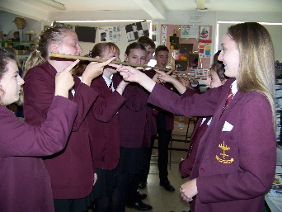

Activity 2 – What is the Derwent Valley Mills World Heritage Site?
Aims:
- Introduce different UNESCO World Heritage Sites
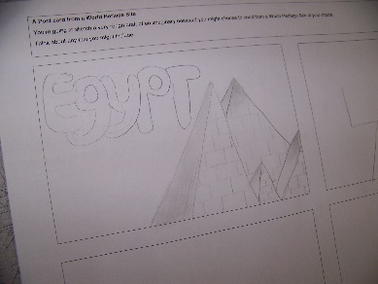
- Begin to understand what is and what makes the Derwent Valley Mills World Heritage Site (DVMWHS) special
Resources:
- What is the DVMWHS Powerpoint
- Postcard / Instagram post template per student
- Pencils / pens
- The Story of the Derwent Valley Mills World Heritage Site Children’s video (http://www.derwentvalleymills.org/discover/learning-for-all/learning-schools/teaching-resources/childrens-guide/)

Activity Guidelines:
- Work your way through the self-explanatory PowerPoint.
- At slide 6 and 7 it introduces the idea of making an ‘Instagram post’ about a world heritage site, a paper template for this is in the resources or you can design and write a postcard instead (again template provided). Slide 8 gives more examples of world heritage sites to be used as inspiration for this task.
- If appropriate you could also use the video “The Story of the Derwent Valley Mills World Heritage Site” to help communicate what makes this place special. This can be accessed from our website at: http://www.derwentvalleymills.org/learn/learning-schools/teaching-resources/childrens-guide/ The video lasts 10 minutes 17 seconds.

Activity 3 – Production manager game
Aims:
- Reinforce teamwork, communication and processing skills.
- Focus on refining processes and communicating when working as a team
Resources:
- Students arranged in a large circle
- Sponge ball or other small soft ball for throwing and catching
- Timer
Activity Guidelines:
- The idea is you don’t give too much information to start with but you’re looking at working well as a team to make tasks efficient and work well.
Basically the rules are:
- Everyone touches/holds the ball says their name and the name of the next person they are throwing to and passes it on. Start in a circle, one person holds the ball and starts saying their names “Ingrid to George” throws ball and then fold arms (or sit down) when you have touched it.
- Time how long it takes to go around everyone until everyone in the group has touched the ball and said their name and who they have thrown it to.
- Do it again and see if it is quicker (Normally this will be faster so reflect on why is this; getting used to the process, routine and task, familiarity.
- Invite the group to suggest ways you can refine this to make it quicker; If you need to support ask questions like: Think about what is slowing this down? Where is time lost? Listen to ideas and try different ones out timing them. Whose idea works best? Can we combine ideas? Don’t provide ideas let the group come up with them and try things out but things that work include: Moving people closer together, passing to the person next to you around the circle instead of throwing it across the circle etc.
- Can we get rid of any unnecessary parts of the process without completely changing the task? Does that make it quicker? Again don’t give the ideas but these have worked: Perhaps not saying the other person’s name just your own? (Clue: The absolute quickest way is for all to put one finger on the ball in the middle, say their name and someone else’s name simultaneously!)
- What is the absolute fastest we can do the task?
- Reflect on the different stages of how we did it – what worked? What didn’t work etc. How did we communicate? How well did we listen to each other? Who came forwards with ideas etc. If appropriate with older students you can use the ‘Tuckman’s stages of team development’ as a bit of an explanation to how teams develop: see below and link at the bottom (forming, storming, norming, performing, adjourning).
- Really useful to reflect and link to the Derwent Valley Mills World Heritage Site too as the birthplace of the ‘factory system’ where people had to get faster at processing, production and all contributing to the manufacturing of a greater whole.

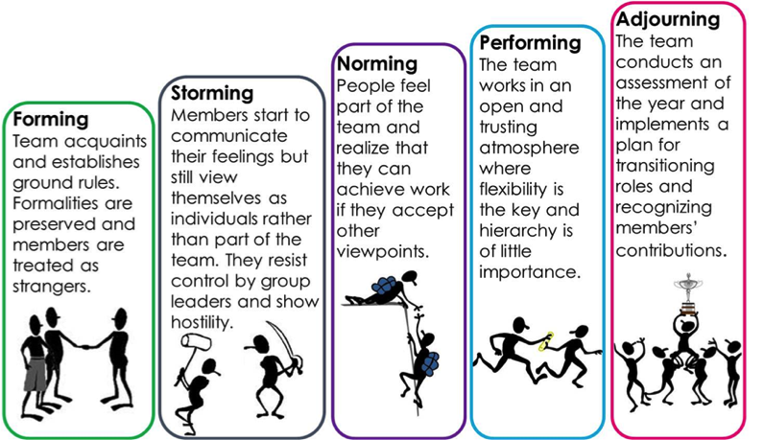
Credit: https://ns4business.com.br/tuckmans-stages-of-group-development/
Activity 4 – Introduction to the project
Aims:
- To introduce students to the ‘Young Entrepreneurs’ project and their role within it.
- Students will know what is expected of them by the end of today’s activities and at the different stages throughout the project.
Resources:
- ‘Introduction to Project’ PowerPoint
Activity Guidelines:
- The PowerPoint is designed to be self-explanatory, however you will need to amend or add to the slides to make it more pertinent to your group and their focus.
- Slide 3 assumes that Day 1 activities will be completed in 1 day, if this is not the case this slide will need amending.
- Slide 4 lays out a time frame for the whole project, please amend this to suit your specific time frame and who you are working with.
- Slide 5 refers to ‘The Tenner Challenge’, (A ‘Young Enterprise’ project for full details see: https://www.tenner.org.uk/) whereby each company gets £10 to invest, buy materials, stock goods etc. This introduces the students to the idea of budgeting, investing in a business and making a profit in true entrepreneur style. You can choose to physically give each company £10 to purchase items not available at school or in their setting or give them a budget of £10 that needs to be accounted for in the resources they use or order from school or in their setting.
- Slides 6 to 19 relate to all the different mediums you could choose to work in. We have covered digital products, clay, screen printing and graphic design. It may be that you are able to give your students a choice between all / many different mediums, or you may need to choose a specific medium for them, depending on your skills, access to professional artists, resources available at school or the curriculum area you link this project to. Therefore, you will need to remove the slides that are not relevant to your students. Alternatively, you may want to work in a medium not mentioned (e.g. photography). If so just insert some of your own slides to give examples of work in this preferred medium.
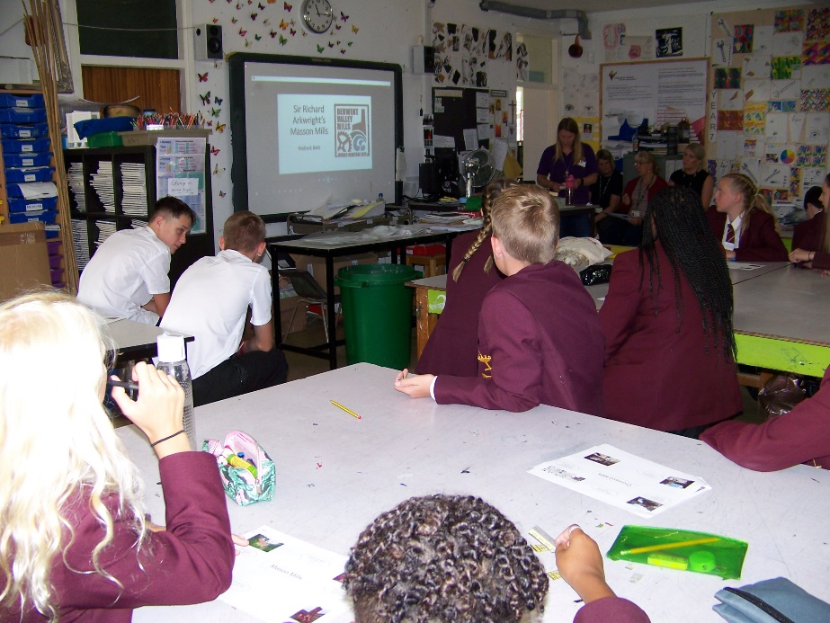

Activity 5 – Site videos and discussion
Aims:
- To know a little more about different sites along the Derwent Valley Mills World Heritage Site.
- Start to view the sites in relation to what they can offer in terms of stimulating inspiration for a product to make.
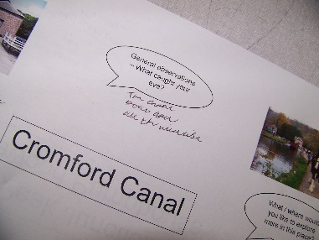
- Be able to make a case for or against visiting a particular site.
- As a class come to a conclusion as to which site you will visit.
Resources:
- DVMWHS sites video (please check which are open and
operational)
- Site student notes sheets, 1 set per pair or small group
- Pencils / pens
- Coloured sticky dots (can mark with a pen if no dots available)
- A3 voting sheet for each site
Activity Guidelines:
- The DVMWHS film gives a snapshot of a few of the different sites along the valley it includes Masson Mills, Cromford Mills, Cromford Canal with the Birdswood canal boat, High Peak Junction and Belper North Mill.
- The project works best if you are able to let the students choose the site they want to visit, as it contributes to their sense of ownership over the project. However, if for any reason the students are not able to visit certain sites (e.g. accessibility, availability of site etc.) you may want to restrict the clips to the sites they can choose from.
- Before showing the film give out a set of site discussion sheets to each pair / small group. Explain that the students are going to watch a film showcasing the different sites and that their job will be to make notes on these sheets about the different sites. “What caught their eye? What might inspire you? What would you like to investigate more?” etc.
- Also explain that after watching the film clips, they will have an opportunity to ‘pitch’ their preferred site to the rest of the class, before the whole class will vote on the site they would like to visit. Therefore, it’s important for them to watch carefully, make notes and prepare their persuasive argument for or against visiting a site.
- Watch the first ‘site’ and then pause and allow the students take notes and discuss in their pairs or small groups. Then watch the next site and so on.
- Once everybody has been able to ‘pitch’ their preferred site to the class and everyone has had their say it’s voting time. Place the A3 voting sheets for the different sites around the room. Choose a voting system that suits you, either give each student 5 sticky dots, which will enable them to spread their votes over all the sites if they don’t mind where they go, or they could use all the dots on 1 site if they had an absolute favourite, alternatively students could vote only once, perhaps by signing their initials / making a mark on only 1 of the site sheets.
- Agree which site they will be visiting and discuss how they feel about this. Issues including making compromises, having to change ideas, being flexible etc.

Activity 6 – Teamwork clips and team challenge
Aims:
- To realise that good communication is key to effective teamwork
- To put this knowledge about communication to the test and successfully complete a communication based teamwork challenge.
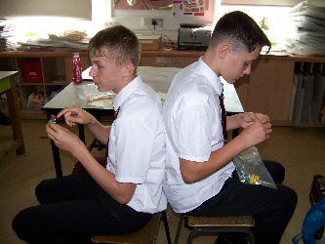
Resources:
- The 2 film clips, highlighting the need for good communication skills
- 10 sets of Lego kits, each kit needs to contain 2 bags of Lego, each containing 10 Lego blocks that are identical (the 10 sets do not need to be identical only the 2 bags within each set)
- Alternatively, if you do not have Lego you can use paper and pencils to complete a different but comparable challenge.
Activity Guidelines:
- The first clip “funny communication skills” (1 min 17 secs) is quick but super effective, eliciting the importance of precise communication at the correct time, without which terrible things could happen!
Funny communication skills: https://www.youtube.com/watch?v=ixSUBl1WNxk
Teamwork gone wrong: https://www.youtube.com/watch?v=2mrzcgmvbO0
- In the second clip students may be able to recognise their own behaviour or that of others. It really does highlight that everyone has a part to play in how they contribute to a team, whether it’s how they choose to speak to people (or choose not to speak up), how their body language can effect a group, right through to the effects of turning up late or disengaging in the task at hand.
- With students’ new-found realisation of the importance of precise communication and the importance of everyone’s attention and involvement in a task they can have a go at either the Lego or Draw a Picture challenge.
- Lego challenge – put students into groups of three. 2 students to sit back to back, with the third standing in a position to clearly see the other 2. Give the students sitting a set of Lego, they need a bag (of 10 matching bricks) each. Explain that 1 student is going to take on the role of designer and the other will be the builder. The 3rd student standing will be the observer. The ‘designers’ have 2 minutes to make a model out of Lego (depending on the complexity desired by yourself I would limit the number of bricks they are allowed to choose to perhaps 5). Once the model is complete the ‘designer’ then needs to give the ‘builder’ instructions on how to make an exact copy of their model. To make this challenge harder you could make the rule that the builder can only follow instructions and not ask questions. When the ‘builder’ has completed making their model they can turn to look and compare with the designer’s model. The observer can also give feedback on how well they communicated with each other, what went well and what did not go so well. The students can then rotate around the roles. As a class discuss how they found the different roles, “What was it like to observe, but not be able to help?” “As the builder, what was it like following instructions, especially if they were not clear and you could not ask questions” “As the designer what did you do to make your instructions as clear as possible?”
- Draw a picture challenge – this challenge takes the same format as the Lego challenge, but instead of making a Lego model the designer has to design a house by drawing it on a piece of paper (you might need to make the rule that it cannot look like a ‘traditional’ house of 2 windows upstairs, 2 downstairs and a door in the middle). The designer would then tell the house ‘builder’ how to draw the house, with the 3rd person observing as before.

Activity 7 – Company roles
Aims:
- To understand the 3 key roles within a company: project manager, marketing manager and product design manager.
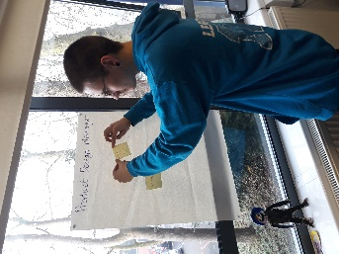
- To identify the skills and qualities needed for each role.
- To self-identify which role they think they would be best suited to.
- To form companies based on people’s skills and qualities.
Resources:
- Flip chart paper, pens and blue tac.
- Post it notes - enough for a few per person.
Activity Guidelines:
- On 3 pieces of flip chart paper write titles of project manager, marketing manager, or product design manager on each sheet and place on the wall around the room. If you wish you could add additional roles such as ‘finance manager’ etc.
- Go through the different roles one at a time, through discussion ensure that the students know what the different roles would entail. As well as ‘tasks’ they would perform ask the students to think about what skills and qualities they would need to perform that role well. Students can then write notes or key words onto the post it notes, before coming to place them on the flip chart paper. You can then pull the ideas together and feedback to the class on the ideas they came up with.
- When all 3 roles have been discussed and recapped on, ask the students to go and stand next to the role that they think best suits their skills and qualities – encourage them to be honest and self-reflective.
- From these 3 groups the students will need to come together to form a company. They need to make sure they have a broad skill set in their company (so probably one person from each of the job areas). How this is done is up to you, either you can choose a couple of students from each ‘job’ and put them in a company, or students might be able to group themselves. Companies should probably not be larger than 6 to 8 students, or they become difficult to manage and work together.

Activity 8 – Reviewing logos and company names
Aims:
- To recognise different design options when designing a company logo
Resources:
- Logo quiz sheets, a couple per company
- Logo quiz answer sheet
Activity Guidelines:
- Give out a couple of quiz sheets to each company, when everyone has them give the class perhaps 10 minutes to have a go at filling in a company name for each logo given.
- After the set time go through the answers with the class.
- Discuss with the students what they notice about the logos “Is the name of the company/product used on the logo?” “Do they use abbreviations?” “What colours are used, is it big block primary colours or something else?” “Is the logo made up of random shapes, or recognisable objects?” etc. Draw out what makes logos easily recognisable and memorable.
Activity 9 – Designing individual company names and logos
Aims:
- To work as a team to design a company name and accompanying logo
Resources:
- Paper, coloured pens, pencils or computers
Activity Guidelines:
- Before students start coming up with company name ideas and logos it would be beneficial to remind them of what was decided earlier in the day. “What site are they going to visit, what type of product are they going to make?” “Will this influence their company name or logo?” On past projects one company was called ‘Clay and co’ inspired by the clay products they were planning to make, another company based their name on their initials, whilst another incorporated a water wheel in their design, inspired by what was happening at the mills in the past. There is no right or wrong approach in designing a company name and logo, students just need to remember the basics of logo design and be proud of their company name.
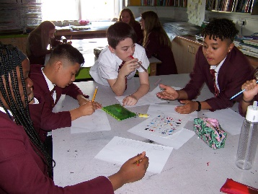

Activity 10 – Forward Planning
Aim:
- To ensure the students know the next steps of the project and what their role will be.
Resources:
- Paper, pens, pencils, computers
- A3 plastic folder per group
Activity Guidelines:
- This activity is about giving time to embed the days learning, ensuring students are where they need to be and that they know what is going to happen next.
- Students should:
Have a company name and logo
Know their role within the company e.g. who is project manager, product design manager, marketing manager, what are everyone else’s roles? Have jotted this down.
Know where and roughly when they are going to visit the DVMHWS
Have an idea about the type of products they are going to make after their inspirational site visit.
If time the company could jot down their ‘ground rules’ e.g. ways of being with each other, responsibilities to each other etc.
- Hand out an A3 plastic wallet to each group, everyone loves a bit of stationery and it helps to keep the company planning safe and all together!
- Groups to feed-back verbally: their company name and logo design and reasoning, roles within the company. What skills they hope to develop going forwards.

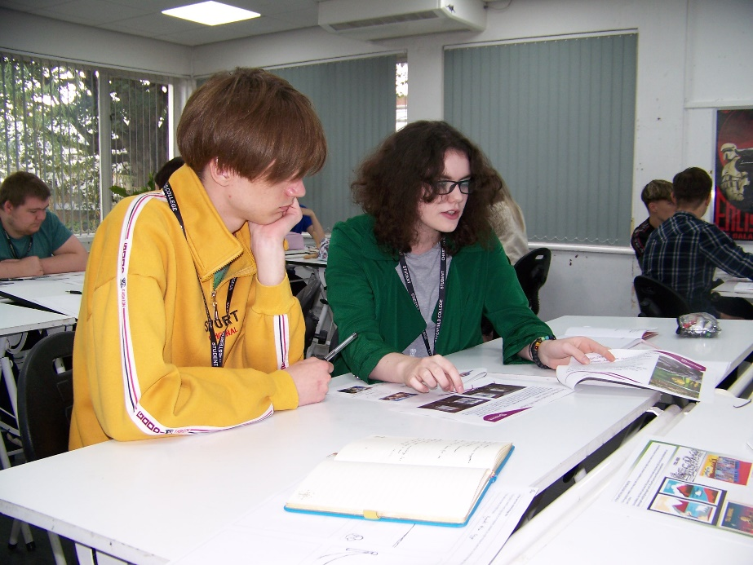

Day 1: Being Young Entrepreneurs: Suggested Timetable of activities

Timing | Activity and Purpose | Resources
9.00 | Activity 1 – Introductions, ice breaking and initial teamwork.  - Name game  - ‘Helium Stick’ bamboo stick co-operation game: installing the idea of team-work, communication, co-operation, different people may have different roles, but everyone needs to be involved, etc. | - Camera and memory stick to take videos and pictures.  - Photo permission forms if needed  - Long Bamboo sticks (1 per group of around 8 people)
9.30 | Activity 2 - What is a World Heritage Site – why is the Derwent Valley Mills World Heritage Site special?  - An introduction to different UNESCO World Heritage Sites and explanation of what makes DVHWHS special.  - Students complete Post Card or an Instagram ‘post’, representing a World Heritage Site. | - Cotton pods / roving / carding paddles etc.  - ‘A postcard from a WHS’ sheets OR ‘Virtual visit’ WHS Instagram blank (1 per pupil)  - Pencils/pencil crayons  - What is the DVMWHS presentation.
10.00 | Activity 3 – Production manager game  - Game reinforcing teamwork, communication and processing skills and the importance of refining processes and communicating tasks when working as a team. | - Ball  - Space to stand the group in a circle
10.30 | Break
10.45 | Activity 4 - Introduction to the project  - Students will be introduced to the ‘Young Entrepreneurs’ project and their role within it. Specifically, what will be expected of them by the end of the day and at different stages throughout the project. | - ‘Introduction to the project’ presentation
11.00 | Activity 5 – Site videos and discussion  - After a brief look at films highlighting the different aspects of the possible sites they can work with, in pairs students will be able to ‘pitch’ their preferred site, before the whole group votes on a site to work with. | - DVMWHS Sites video  - Student site notes sheets (1 between 2)  - A3 site voting sheets  - Sticky dots
11.30 | Activity 6 - Teamwork clips and developing communication  - Selecting a film clip, students to come up with ideas on what they need to do to ensure their group works as an effective team, focusing on communication skills.  - In 3’s students to play the ‘Lego’ or ‘drawing’ communication games. | - Funny communication skills  https://www.youtube.com/watch?v=ixSUBl1WNxk  Teamwork gone wrong  https://www.youtube.com/watch?v=2mrzcgmvbO0  - Sets of matching lego pieces in bags with boards  - Pencils and paper
12.15 | Lunchtime
1.15 | Activity 7 - Company roles  - Time to highlight 3 key roles within a company: project manager, marketing manager and product design manager. Students will need to think of the skills and qualities needed for each role, before self-selecting which role they think they would be best at. Companies to be formed. | - Flip chart paper  - Post it notes
1.45 | Activity 8- Logo’s / company names  - After playing a logo quiz we will discuss common themes for logos and company names. | - Logo quiz sheets
2.05 | Activity 9 - Designing own company name and logo  - In their company students come up with a company name and logo. | - Paper, pencils, coloured pens  - PCs, laptops, tablets if digital design
2.40 | Activity 10 – Forward planning and reflection on the day  - Discussion and decision on who is going to take on different roles within the company. Students start to think about what products they might want to make, what they will be looking for on their site visit etc.  - What skills will be important? | - Paper, pencils, coloured pens  - A3 plastic wallets 1 per group
3.00 | Close the session

Day 1 – Being Young Entrepreneurs List of Resources to download
- Activity 2 – A Postcard from a WHS
- Activity 2 – Virtual visit WHS Instagram blank
- Activity 2 – What is the DVMWHS presentation
- Activity 4 – Introduction to project presentation
- Activity 5 – A3 site voting sheets
- Activity 5 – DVMWHS Sites video
- Activity 5 – Student site notes sheets
- Activity 8 – Logo Quiz
Download from http://www.derwentvalleymills.org/discovery/learning-for-all/learning-schools/teaching-resources/young-entrepreneurs-project/

Day 2: Site Inspiration Visit
Location: Selected site in the Derwent Valley Mills World Heritage Site
Students: Maximum around 30
Curriculum Area: Art, design, business, extra-curricular or enrichment.
If you are letting students choose which site they are visiting as part of this project there will be a delay between session 1 and session 2 whilst you organise the visit. If, however you are telling the students where they are visiting then this session can be planned to take place very soon after session 1. It is best to give yourself as much time as possible in order to liaise with staff on site, especially if you require them to give you a tour, book a learning space etc. You may also need to liaise and find an appropriate date and time if you are working with an external artist.
The main purpose of the visit is for students working in their ‘company’ groups to tour the site, finding out about its history and heritage and role in the Derwent Valley Mills World Heritage Site (DVMWHS). They will be inspired by and gather the information, facts and data they need to be able to develop the products to meet their brief and what they have planned within their company. They will be developing key communication, co-operation, teamwork and creative skills possibly with the support of onsite heritage experts and creative practitioners. They may also do some customer and market surveying.
If you choose not to use on site staff to guide the pupils around the site explaining its history and heritage then you will need to make sure that you are happy to do so, which will almost certainly involve a pre-visit to the site.
Learning Objectives:
  - Have visited their chosen visit site. Understand the key historical and heritage features of this site and its role in the DVMWHS story.
  - Have worked effectively as a team, making decisions about information, data and activities they need to gather to be able to manufacture and complete their products. This will involve working with the context and setting and responding appropriately.
  - Work together carrying out the roles and responsibilities required of them within their company in a timely and focused way.
  - Develop communication skills to make use of the heritage experts available to them and the creative practitioner asking for advice, support, guidance where required.
  - Develop site responsive designs that can be turned into screen print designs.
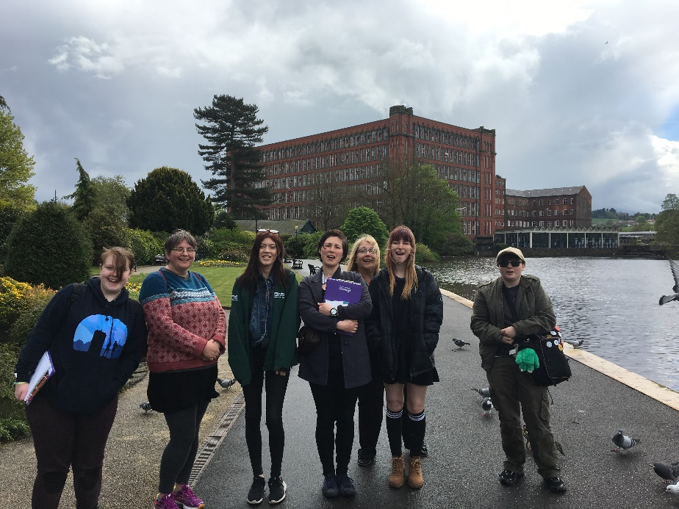
Two different suggested timetable of activities options are provided on page 21 - 23

Activity 1 - DVMWHS quiz
Aim:
- To recap on knowledge students have about the Derwent Valley Mills World Heritage Site, especially as it may be some time since session 1.
Resources:
- Site visit quiz sheet per group / pair
- Site visit quiz answer sheet for lead adult
- Pens / pencils
Activity Guidelines:
- After arriving on site, being welcomed and giving a health and safety introduction to the site you are using for the day, go straight into the quiz.
- It’s very straightforward and can be completed in company groups or pairs. It will jog the students’ memories of what the DVMWHS is about and highlight any areas that you think need going over again or reinforcing.
- After the quiz it would be worthwhile talking a little more about the site you are visiting, so they know briefly what it is all about before going on a more in depth tour of the site.

Activity 2 – Design / product brief recap
Aim:
- To have a clear understanding of the design/ product brief.
- To recognise what is involved in key design/product development processes, along with any limitations they may have.
- To know what their key roles are within the company, this may shape what they do during the day if they need to delegate different jobs to do.
- To take responsibility for their learning for the day and set themselves up to succeed, with their own ’tick list’ of what they need to gather/ find out, by the end of the day.
Resources:
- A clear reminder of the design/ product brief, this could form part of a PowerPoint or be at the top of a ‘plan for the day’ sheet that the students need to fill in.
- If appropriate it might be useful to show examples of products and demonstrate the processes involved in making them.
Activity Guidelines:
- Students really need to focus in on what the purpose of this day is. Yes, it is to learn about the history and heritage of the site, but this is only so it can feed into the development of their designs or products.
- If students are attempting a design or manufacturing technique that is new to them, or they have little experience in it is important to help the students to realise any limitations they may have. For example, if students have chosen to Screen Print tote bags, they need to know or be reminded of the process and the fact that any design ideas they develop on site will need to be simple if they are going to be successful. Or if computing students are looking at developing a virtual tour, is it reasonable for them to think they can recreate the whole mill complex, or should they be focussing on a particular area.
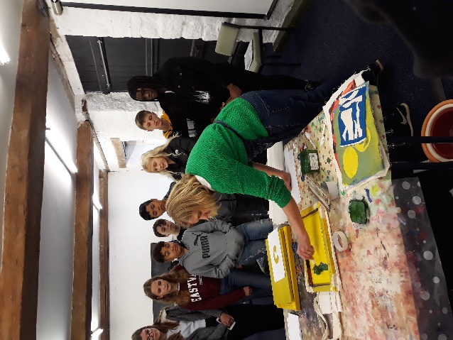
- If you are working with an artist you could ask them to give a demonstration, suggest things to look for, provide additional guidance here. You could also invite the site staff to remind the students of the brief and provide some immediate feedback to initial questions.
- After the tour around the site students will have more time to look at their product planning and gather appropriate information, inspiration, market research etc.

Activity 3 – Tour of site
Aim:
- Familiarise with the location, the key features and heritage of the site.
- Students to record their initial reactions to places of interest, current styles used by the heritage site, views, merchandise currently available etc.
Resources:
- Gathering inspiration worksheet, 1 per student, could be A3 or A4
- Clip board per student
- Pens, pencils, including coloured ones if appropriate
- Cameras / phones as appropriate
- Plain and coloured paper and elastic bands to ‘make your own sketch book’ with paper and pockets to gather information (provide sticky tape) or use their own sketch books.
Activity Guidelines:
- Unless you are very familiar with the site you are visiting it is recommended that you book a tour of the site with an appropriate guide.
- If using a guide make sure to brief them what your purpose of visiting the site is, to ensure you receive an appropriate tour. Whilst students need to understand the history and heritage of the site, depending on their brief they may need to know specific information, or some detail can be omitted.
- For example if students are designing a digital quiz based on the history of the site they will need facts, figures and dates, but if they are designing key rings to be sold in the on-site shop they will need to make sure that they have time to visit the shop and talk to staff there. Remind the students that they will have time go back to different parts of the site to gather more detailed information in the afternoon.
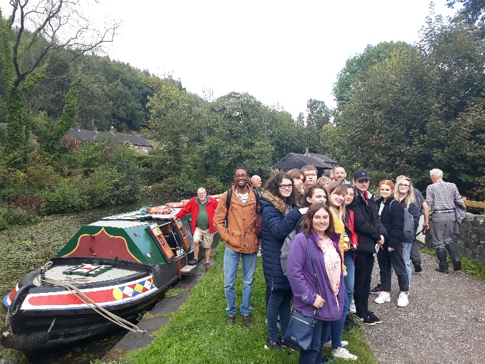
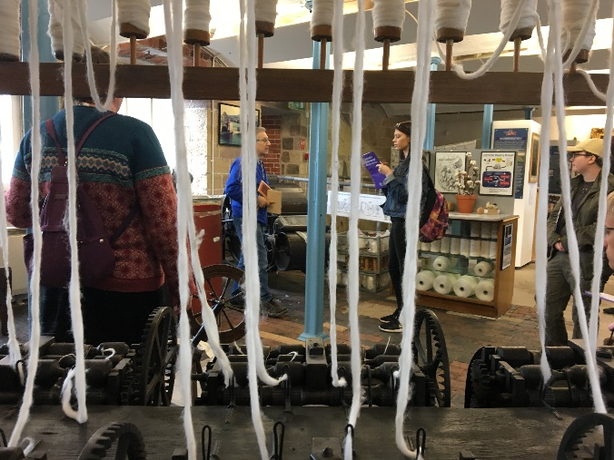
- An information gathering sheet (found in resources) is a good way to focus the students whilst on their tour of the site. It can be amended to suit your students’ requirements.

Activity 4 – Product planning, gathering additional information and inspiration
Aim:
- For students to have all the information and inspiration they need to develop their design / product back at school /college.
- To work as a team developing their roles within their company structure.
Resources:
- This is dependent on your students’ style of working and the information they need to take back to school, it could include: cameras / phones, sketch pads, ‘mini scrap books’, pens, pencils, clip boards, design/mood boards, etc.
Activity Guidelines:
- A good place to start with this is to ask students to recap on what they know about the site so far and what their thoughts are on how they can develop their design and product ideas to match their design brief. A tick list of what they know/ have got or what they still need to do would be useful to focus students’ minds on the task ahead.
- Companies designing ‘quizzes’ or ‘interpretation boards’ may need to go in search of more facts and figures, whilst those planning to make products that a visitor might buy on site may want to visit the site shop, or do market research and design a quick questionnaire they can use with visitors on site.
- Companies may delegate jobs, according to students’ roles within them. The ‘marketing manager’ may want to take the lead on speaking to members of the public, whilst the ‘finance manager’ may take the lead on visiting the site shop and looking at prices of items already for sale, whilst the ‘product design manager’ may want to lead a small group around the site gathering inspiration for specific design ideas.
- Try to allow some freedom to explore and take responsibility for the information gathering, sketching, photographing, discussing and driving their own progress.
- If you need guidance on working with sketch books or how to make your own Sketch Book or Artist’s book there is some fantastic guidance and video instructions available from Access Art:
  - https://www.accessart.org.uk/the-sketchbook-journey/
  - https://www.accessart.org.uk/making-sketchbooks/
  - DrawAble: Making an Artist’s Book by Paula Briggs
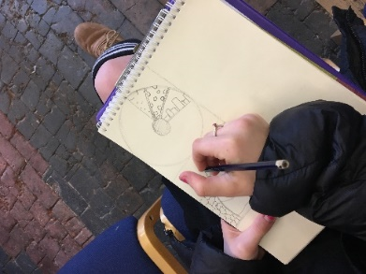
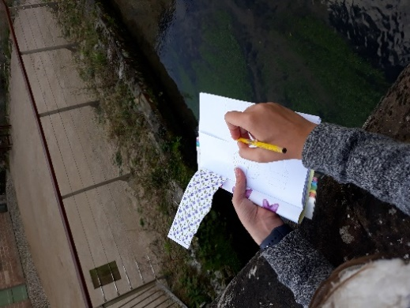

Activity 5 – Reflection on the day
Aim:
- To reflect on what they have learned during the day, about themselves, the site, and working as a team.
Resources:
- A blank postcard per student
- Pens or pencils
Activity Guidelines:
- Students to address and write themselves a postcard about what they have learnt during the day, it would be great if they could actually be posted home!
- After what will have been a busy day, this activity allows students to focus in on what they have learnt, not just fact and figures, but about themselves and the ‘hidden’ skills they have developed such as teamwork, research or creative skills.
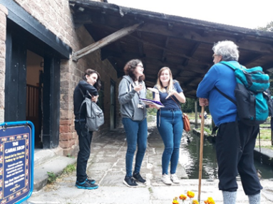
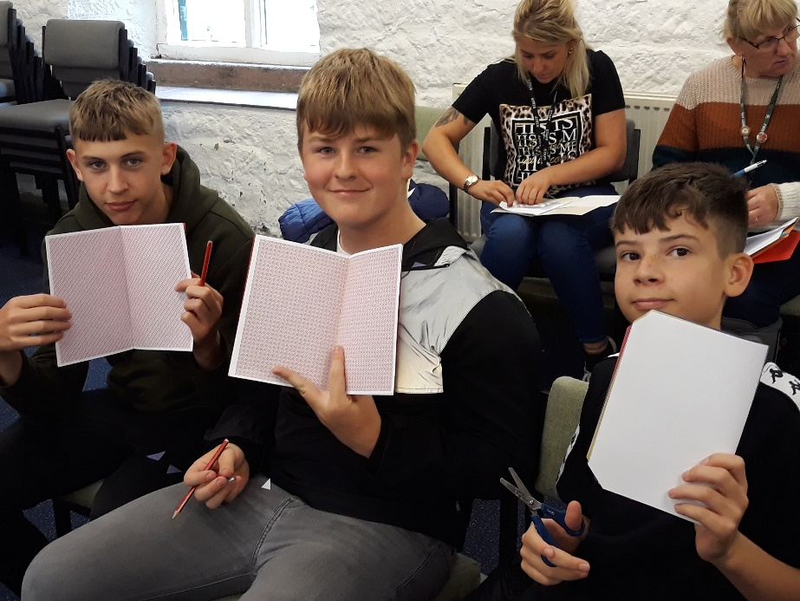

Day 2: Site Inspiration Visit: Suggested Timetable of activities 1
Digital Brief at Belper North Mill
Timing | Activity and Purpose | Resources
9.30 | Health and Safety briefing for the day  Activity 1: Young Entrepreneurs a Quiz:  Students get into their company groups. Quick quiz about the DVMWHS, Belper and the project. | - Quiz questions  - Answer sheets  - Pencils  - 6 clipboards
9.50 | Activity 2: Design / Product Brief Recap  Planning the creation and manufacture of products:  Review the design brief presentation.  Thinking about products. We have initial ideas from session 1 but we need to make sure that the product your company makes is something that will bring the site to life for audiences your age or younger. Set yourselves up to succeed and review the skill sets in your group. Company roles. | Project dependent:  - Laptop  - Projector  - Marker pens  - Flip chart paper  - Blank paper  - Clipboards
10.15 | Break
10.30 | Mill guides leading:  Activity 3: Tour of the site  Belper North Mill lead the students on a tour of the mill explaining the key features of the building and the key facts of the site indoors and outdoors. | - Clipboards  - Pencils  - Site inspiration sheet (1 each)
12.00 | Lunch
12.30 | Activity 4: Product planning, gathering additional information and inspiration  The company groups will finalise exactly what product they think is achievable, what information they need to gather whilst at the mill to ensure they can create their products. Roles, responsibilities and processes to be decided within the company groups. | - Pencils  - Paper
1.00 | Activity 4: Gathering information and inspiration.  Working in company groups each will gather the information they need which might be photographs, facts, measuring and recording, images etc. Working with support from and seeking advice from the site staff at Belper North Mill students will be responsible for making sure they have what they need. | - Digital cameras  - Paper  - Trundle Wheel  - Tape measure  - Paper  - Clipboards
2.15 | Activity 5: Reflection on the day  Students will write and address themselves a postcard detailing what they have learned during the day – about the site, about themselves, about working as a team. | - Postcards  - Pen
2.30 | Depart site

Day 2: Site Inspiration Visit: Suggested Timetable of activities 2
Screen Printed Products at Cromford Mills
Timing | Activity and Purpose | Resources
9.30 | Health and Safety briefing for the day and welcome to site at Cromford Canal.  Introduction to the day – decision making tick list: What do we need by the end of the day?  Activity 1: Young Entrepreneurs a Quiz: Students get into their company groups. Quick quiz about the DVMWHS and the project. | - Safety bag / throw line / first aid kit  - Decision making tick list per company  - Quiz questions  - Answer sheets  - Pencils  - 6 clipboards
10.00 | Activity 2: Design / Product Brief Recap  Designing in context  Presentation and demonstration about screen printing, what is effective, the design process in context. What makes for a good screen print?  How can your products connect and represent the site? What are consumers looking for? Chance for the students to discuss in their company groups their product ideas again and roles for the day. | - Resources to support demonstration specific to brief
10.40 | Break
10.55 | Activity 3 – Tour of the Site:  Getting an initial feel for the location, the key features and heritage of the site. Initial reactions and places of interest, current styles, colours, views.  Split into two groups – 1 group to be in the ‘Arkwright Experience’ with mill site staff at 11.00am and the second group to go in at 11.20. When not in the Arkwright Experience spend time in the mill yard, visitor centre and if time view from above at Scarthin Rock. | - Gathering Inspiration sheet  - Clipboards  - Pencils  - Cameras
12.00 | Lunch and shops:  What is currently on offer?  Chance to visit the Shop in the Yard in Cromford Mills to see the current range of products on offer and what is available, prices, merchandising, presentation.
12.45 | Activity 4: Product planning, gathering additional information and inspiration  Product Planning  Students will create their own sketch books to gather their inspiration in. They will discuss as a company what they want to focus on based on their morning’s introduction to the site. Groups will then operate around the mill yard and locate themselves to carry out photography, sketching, market research, image design etc. | - ‘Making sketch books’ resources  - Pencils  - Clipboards  - Cameras  - Notepaper  - Pastels, charcoals, pencil crayons etc.

2.00 | Your investment!  They will need to decide during this slot exactly what they want to make product wise and put an order in as to what they want to invest their company £10 on (number of bags, t-shirts, envelopes, card etc.)
2.15 | Activity 5: Reflection on the day.  Students will write and address themselves a postcard detailing what they have learned during the day – about the site, about themselves, about working as a team. | - Postcards  - Pens
2.30 | Depart site

Day 2 – Site Inspiration Visit List of Resources to download
- Activity 1 – Site visit quiz
- Activity 1 – Site visit quiz answers
- Activity 3 – Gathering inspiration worksheet
Download from http://www.derwentvalleymills.org/discovery/learning-for-all/learning-schools/teaching-resources/young-entrepreneurs-project/

Day 3: Production Day
Location: Participating School or College
Students: Maximum around 30
Curriculum Area: Art, design, business, extra-curricular or enrichment.
This third session requires you to have in place all the resources that your students may need to either complete their designs or build up the production of items ready for the sales event. Students will be working in their company groups possibly alongside an external artist to design / make the products outlined in their product briefs. They will be developing key art / design skills alongside developing the teamwork and communication skills required to be a successful, entrepreneurial company. During this session (or before the next) time needs to be given to the students to think about and prepare for session 4, the sales event.
Learning Objectives:
- To understand how the products and work of each company will be evaluated and scored.
- To develop designs and make products inspired by the DVMWHS site.
- To investigate product costs and production costs and liaise with professionals.
- To plan times and deadlines collaboratively to meet the sales event deadlines.
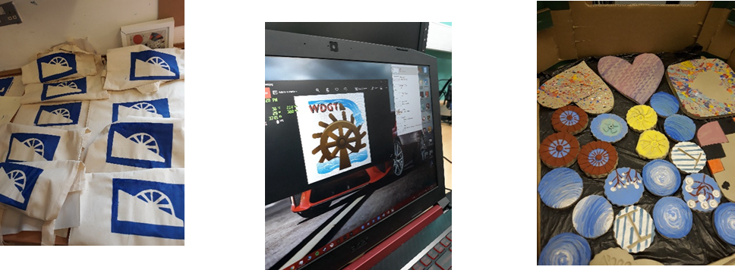

Activity 1 – Product brief recap and look ahead to how the companies will be judged
Aim:
- To have a clear understanding of the project brief and how their product needs to be designed and manufactured to meet this brief.
- To know the criteria on how their company will be judged after or during the sales event.
Resources:
- Product brief (digital version or paper)
- Any ‘scoring’ criteria to be used during session 4
Activity Guidelines:
- Discuss with the students what they can remember about the project brief, if needed, share with them a copy of the brief they were given at the start of the project.
- Explain that session 4 will be a sales event when they will be assessed on how well they have met the brief. This may be in the format of a ‘Dragons Den’ style pitch made to industry experts on designs they have completed, or it may be in the form of ‘Who can sell most’ event where companies can sell their products to the general public.
- Share with the students a scoring proforma that you will use to help with the scoring of the companies (examples are given in the resource section).
- The companies will need to start to think of strategies that would suit them. E.g. If they are making a presentation, what format would best show their designs, or if they are selling products do they want a ‘pile it high sell it cheap’ strategy or one that sells more bespoke items at a higher cost? How will they price their items?
- Once the companies have established their strategy for production they can move on to Activity 2.
Activity 2 – Develop and finalise design ideas
Aim:
- To get all members of the company contributing to the product design ideas and as a company decide which designs will be developed and used for the final production.
Resources:
- Print outs of all photos taken as part of the gathering inspiration activity on the site tour.
- All sketches and notes made by the students on their site tour.
- Large pieces of paper, pens and pencils.
- Any market research gathered on site tour.
Activity Guidelines:
- Depending on the products being made you may need to remind the students of any potential limitations or opportunities to their design process. For example, if they are producing screen printing cotton tote bags designs need to be kept simple. Alternatively, if they are making clay coasters have they thought about designing, making and selling them in sets or pairs, to up sell their products? Remind them to look at any market research they did ‘What items would the general public like to buy?’ How much might they be prepared to spend? etc.
- Companies will then need to finalise their design ideas. If there is a difference of opinion on the final designs, how will their company ensure that a fair decision is made, will they all vote for a preferred design, or will it fall to the ‘Product Design Manager’ to make the decision?
Activity 3 – Production of final designs / items
Aim:
- Companies to produce their final designs or manufacture products to sell.
- Companies to plan their time and individual duties to utilise the time they have to produce their products.
- Students begin to understand how efficient processes (a factory system) could lead to increased productivity and potentially increased profits.
Resources:
- This will depend on the products the different companies are making, but may include a variety of materials and crafting equipment, or laptops/ computers, access to particular software etc.
- If possible it may be that you need a variety of resources for the students to choose from, for example if the students are making clay items will they want / need magnets to make fridge magnets, or felt pads to go on the bottom of coasters etc.
Activity Guidelines:
- Depending on the production process, this activity may need additional time after today’s session e.g. putting the felt pads on the coaster once it’s been in the kiln. Or companies practising their presentation skills ready for their sales event.
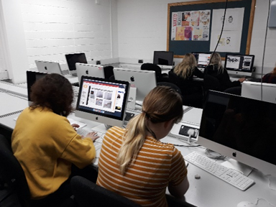
- The companies may choose to organise themselves like a production line, akin to the factory system in the Derwent Valley Mills, with each person responsible for a different role in the production line. Or they may prefer a one person one product approach, where individuals are responsible for the production of an item from start to finish.
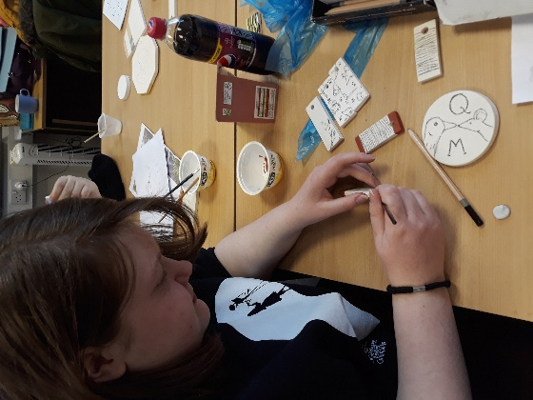
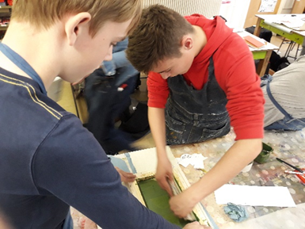
Activity 4 – Next steps, preparing for the sales event
Aim:
- To ensure every student knows what they are personally responsible for in preparing for the sales event.
Resources:
- To do lists
- Product score cards
- Costings sheet
Activity Guidelines:
- Whilst it may be tempting for students to work on ‘production’ right to the end of the day it is really important that time is saved and given to thinking about how the students need to prepare for the sales event, especially if you are not planning to give them any future ‘lesson time’ to do this.
- Again any ‘to do’ lists will be quite different depending on whether the sales event is a ‘dragons den’ pitch or presentation of design ideas, or a ‘market place’ event where companies will be selling their products to the general public, either way it may be the time when the ‘Marketing Manager’ has to step up and take the lead organising their company and what needs to be done.
- For ‘market place’ events, students will need to consider and assign people to be responsible for:
  - How will the event be advertised? - can posters be made and put up at the venue, could letters / texts go home to tell students’ families about the event etc.
  - Do the items made need any packaging?
  - How will the items be priced? How will people know the prices? Will they discount them towards the end of the sale? Do they need to create a ‘price list’?
  - Is the stall outside, is there a wet weather alternative?
  - Do they need a float for taking monies?
  - How will they display their items? Are any additional items needed?
- For Sales pitch events, students will need to consider and assign people to be responsible for:
  - Who will make sure any digital presentation is finished?
  - What ‘hardware’ is available at the presentation venue, do they need access to a laptop and projector, will it go on a memory stick etc.
  - Do they need to print out any design, posters or examples?
  - Which student is going to lead which part of the presentation?
  - Will they have any sample items that they can hand around to the judging panel?
  - When will they practise their sales pitch presentation?

Day 3: Production Day: Suggested Timetable of activities
Timing | Activity and Purpose | Resources
9.00 | Activity 1 – Product brief recap and look ahead to how the companies will be judged  Students arrive – Reminder of the design brief and company groups  - Look at your information research  - Look at your photographs  - Look at your market research  - Final decisions on product type/design process and how selections will be made for the company | - Product brief (digital version or paper)  - Any ‘scoring’ criteria to be used during session 4 1 per student.
9.20 | Activity 2 – Develop and finalise design ideas  In company groups working on the final product designs, sketching out and assigning roles.  - If have an artist provide input on appropriateness, practicality of ideas.  - Might need additional demonstrations or support.  - If have a heritage expert on hand, ensure accuracy or that it is meeting the client brief. | - Photos taken on site visit  - Sketches and notes from site visit  - Paper, pencils, pens  - Access to computers/digital software
10.30 | Break
10.45 | Activity 3 – Production of final designs / items  - In company groups working on designs or products digitally or drawing and how these will be pitched and presented or actually making products (clay, screen printing) | - Will be dictated by the artistic medium
12.00 | Lunchtime
1.00 | Activity 3 – Production of final designs / items  - In company groups working on designs or products digitally or drawing and how these will be pitched and presented or actually making products (clay, screen printing) | - As above
2.15 | Break
2.30 | Activity 4 – Next steps, preparing for the sales event  Company finances:  - What will be our charges? What will the products cost to the shop? What will the products cost to the customer?  - What might be our anticipated profits?  Presentation for a pitch:  - Roles and responsibilities.  - Preparing presentation and setting deadlines.  Planning for a sales stall:  - Roles and responsibilities.  - Preparing to set up a stall and setting deadlines. Additional equipment needs. | - Action planning Gannt charts/to do lists  - Blank paper  - Access to PCs/Laptops for spreadsheets and calculations.  - Score cards
3.15 | Group progress to date:  Each group to share their ideas, designs, thoughts and processes to dates and their next steps for success
Day 3 – Production Day List of Resources to download
• Activity 1 and 4: Score Card Example
Download from http://www.derwentvalleymills.org/discovery/learning-for-all/learning-schools/teaching-resources/young-entrepreneurs-project/

Day 4: Sales Event
Location: Selected site in the Derwent Valley Mills World Heritage Site/School/College event
Students: Maximum around 30
Curriculum Area: Art, design, business, extra-curricular or enrichment

This part of the project will need to be tailored to your students, the products they have made and the practicalities of involving sites or staff from the Derwent Valley Mills World Heritage Site.
Essentially it is the time that students will have to sell their products, designs or ideas to either the general public, school / college community or industry experts possibly from the DVMWHS.
The success of the companies can be judged in a variety of ways, but ultimately there may only be one winning company.

Learning Objectives:

- To develop sales, marketing and presentation skills.
- Further develop group work skills of communication, co-operation, working to a deadline, sharing workload.
- To have fulfilled their roles and responsibilities within their group in a timely and focused way.
- To have worked towards developing a product or design brief inspired by the DVMWHS.
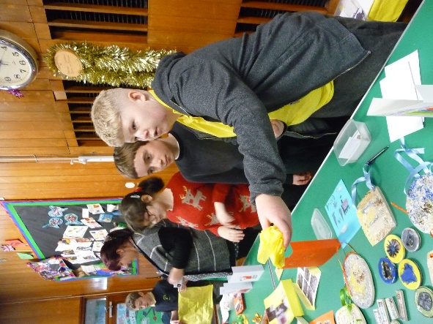
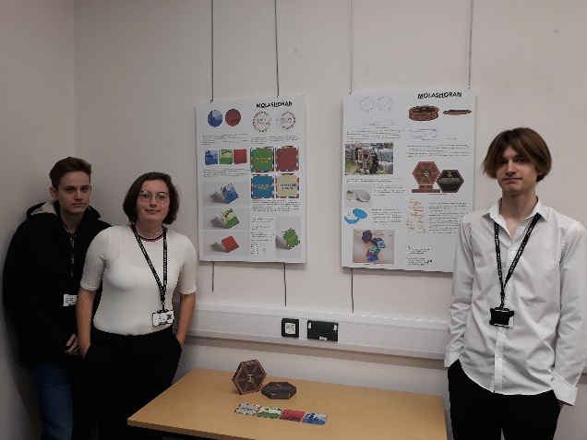
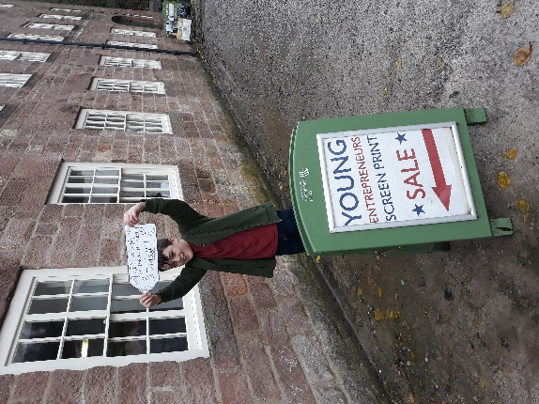

Activity 1: Sales Event or Presentation: Guidelines:
Aim:
- To sell or present the creative products designed as part of the project.
- To develop employability skills for selling or pitching ideas.
- To work effectively as a team.
Resources:
- This will depend on the approach you have decided to take.
- For a presentation pitch: You may need a score card for your panel judges, presentation space, display space, experts to judge, presentation software and projectors, finished designs, product prototypes or poster presentations etc.
- For a sales event: You will need products priced up ready to sell, tables or display areas for stalls, a cash float, price signs, adverts and posters etc.
Activity Guidelines:
You will have previously established how students will be ‘judged’ in relation to their project brief.
- If the brief was to produce items to sell e.g. Clay items inspired by Cromford Canal then it would make sense to have a ‘stall based’ event where the different companies can sell their produce.
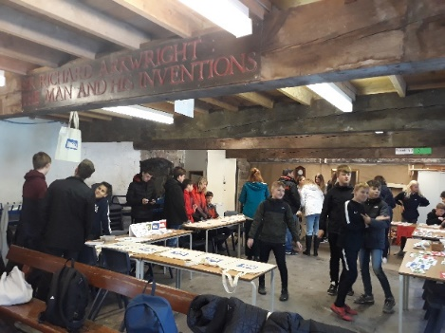
- If the brief is design based e.g. design artwork that could be used on promotional material for Belper North Mill then it may be more appropriate for companies to pitch their designs in a ‘dragons den’ style event.
‘Stall based’ event considerations
- The event could be held in a variety of settings, for practical reasons based on transport, staff and student time it may be that the sales event needs to take place within the education setting, it could take place on 1 day, over the course of a week during lunch time or at a special event e.g. the Christmas or summer fair.
- With negotiation with the site you visited it may be possible to hold the sales event on their site. Students may be able to set up stalls in mill yards, edges of site car parks etc. Whilst this would take more organisation the students will benefit hugely from being able to sell their product at the site that inspired their work. They would be able to sell to friends and family that could visit that day, as well as passing trade from members of the public.
- Again, with negotiation with the site you visited, it may be possible to place some of the produce for sale in the site shop if they have one, along with some interpretation of who made it and why.
- Another possibility might be for students to set up stalls at local markets, in negotiation with local councils or market organisers.
- Wherever the students are able to sell their produce the different companies will need to consider and prepare in advance everything from advertising, price lists, packaging, wet weather considerations to needing a ‘float’ to provide change for any monies taken. This is a real opportunity to develop different employability skills.
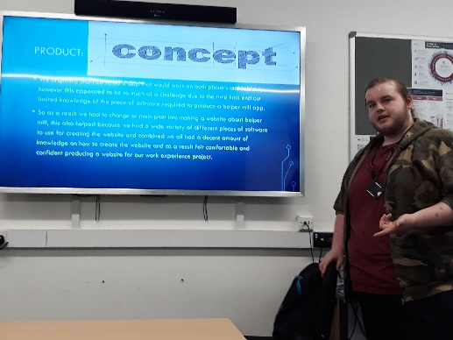
Sales Pitch Style Event:
- This type of event could be held at your education setting or again with negotiation on site in the Derwent Valley.
- If at all possible wherever you hold this event it would be a great opportunity for students to be able to pitch their designs or ideas to a panel of people that could include ‘industry experts’, possibly representatives from the site you visited, local appropriate business people, or the artist that may have worked with you on this project.
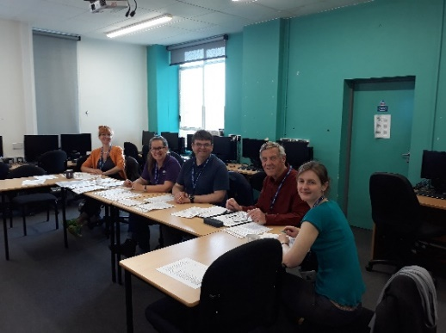
- Companies will need to work hard to prepare their presentation to best show off their work and demonstrate how they have met the design brief. Encourage them to think about matching the different student’s skills with those needed to deliver a professional pitch. Everyone should contribute in some way, but do they all need to speak on the day etc.
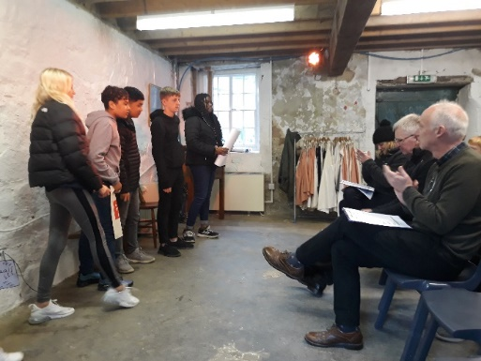
- An example of a panel ‘scoring’ system is included in the resources for session 3 and can be adapted. This helps the panel focus on the same areas across all the different pitches and can act as an aid to elicit information from the companies if they forget to say something. The scoring system needs to be aligned to the brief the students were given. When students are preparing their pitch they could be given a copy of the scoring system to help them structure and prepare their pitch.

Allow time for each group to prepare and set up whether they are giving presentations or staffing a stall of some kind. Whether the success of a company is measured through physically selling the products they have made and the money they take, or through delivering a pitch that highlights their work, or a combination of both, a winning company and runner up can be selected. Certificates and prizes can be awarded as appropriate.
Consideration will need to be given to what will happen to any products that do not sell and what will happen to any monies made. For example, donations to the site, a preferred school charity, school events funds, personal profit etc. This is something that needs to be decided before the ‘sales event’ and can prove to be a real incentive for students to try even harder to sell their products.

Activity 2: Project Reflection and Evaluation
Aim:
- To reflect on learning throughout the project.
Resources:
- Project reflection questions
Activity guidelines:
- To draw the project to a close, time should be given to a little self-reflection. This may or may not be possible to do on the same day as the sales event.
- Ask the students to reflect on a number of questions and jot down their answers on post it notes. These can either be discussed in pairs, small groups or posted onto a print out sheet for discussion and conversation.
- Example questions (included in resources) for reflection could include:
        - What have I learned about the DVMWHS?
        - What have I learned about working as a team?
        - What have I learned about myself?
        - What artistic skills have I learned?
        - Which parts of the project did I enjoy?
        - What did I find difficult, challenging or did not enjoy?
        - How might I use these skills and this knowledge in the future?
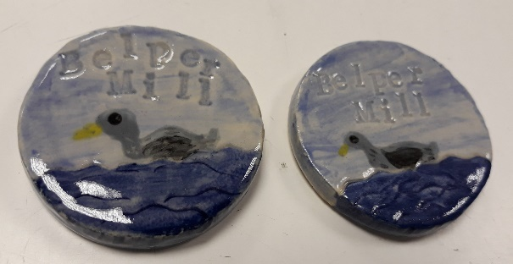
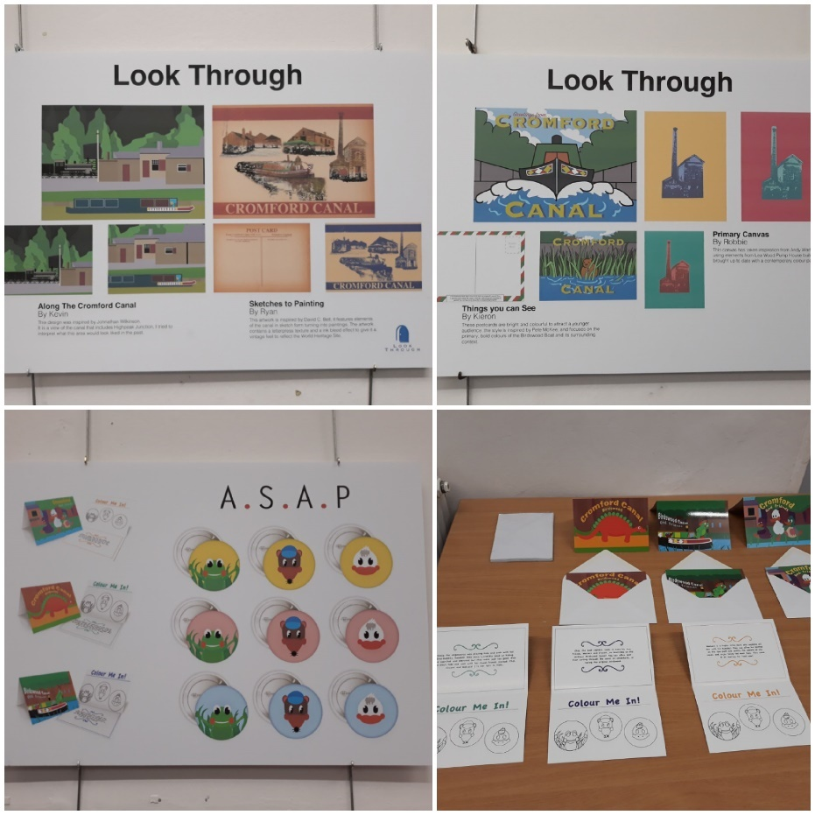
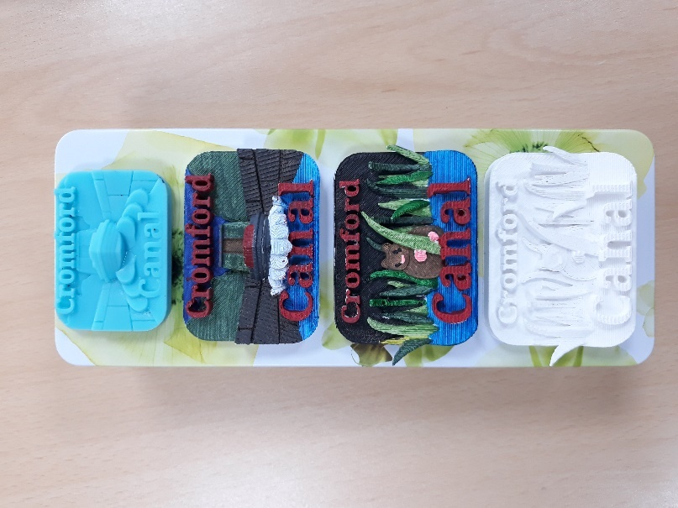

Day 4: Sales Event: Suggested Timetable of activities
Timing | Activity and purpose | Resources
9.30 – 10.00 | Welcome and safety briefing and outline of the day  Preparing the sales stalls  - Setting up sales stalls in the market location.  - Merchandising and displaying the products.  - Devise a ‘rota’ to keep their stalls staffed and be able to have a break two at a time. | - Tables  - Table cloths  - Products  - Price lists  - Posters etc.
10.00 – 10.15 | Break
10.15 – 10.30 | Preparing the sales stalls  - Finish setting up sales stalls in the marquee or yard at Cromford Mills. | - Cash ‘floats’ and till boxes  - Income recording cards
10.30 – 1.30 | Sales and Stalls  - Selling products to visitors to the site or event. | - 5 cash ‘floats’ and boxes  - 5 income recording cards
1.30 – 1.50 | Setting up for presentations and calculating profits
1.50 – 2.50 | Sales Pitch Presentations  Each group to present for 10 minutes with 5 minutes for questions: What is their product? What would they charge for it? How is it inspired by the DVMWHS and the site they visited? What have they learned about teamwork, business and screen printing? | - Laptop, projector, screen, table chairs  - Panel representatives  - Score sheets
2.50 – 3.20 | Review and reflections  - Look at the reflection questions and jot on post it notes.  - What have we learned? About the DVMWHS? About our company? About ourselves. How might we use these skills in the future? Etc.  - Discussion in pairs, as a company or as a whole group. | - Post it notes  - Project reflection questions printed on A3
3.20 – 3.30 | Evaluation and prize giving  - Award the winning ‘Young Entrepreneurs’ their prizes  - Feedback to the whole group | - Prizes for winning group  - Participation certificates

Day 4 – Sales Event List of Resources to download
- Score Cards (see example from Day 3 resources)
- Project reflection questions
Download from http://www.derwentvalleymills.org/discovery/learning-for-all/learning-schools/teaching-resources/young-entrepreneurs-project/
Keep in touch! If you decide to run your own Young Entrepreneurs project, please share with us how you get on.
Email: environmentalstudies@Derbyshire.gov.uk and DVMWHS@Derbyshire.gov.uk
Twitter: @DCCEnvStudies and @DVMillsWHS #YoungEntrepreneurs
Facebook: @DerbyshireEnvironmentalStudiesService @DerwentValleyMillsWHS

